Tab 1

**RESTAURANT SIMULATION PROJECT**

This project uses a probabilistic analysis of business operations to guide the setup of a new restaurant in Downtown Durham. Given the lack of reputation of our restaurant, our goal is to maximize profits, enhance customer experience, optimize employee efficiency, and minimize downtime. Our recommendations are based on statistical analysis of various setup scenarios.

When setting up a restaurant, several key performance metrics must be considered. These include customer satisfaction, restaurant downtime, the number of chefs, the maximum number of seats per table, staff efficiency, order turnaround time, and inventory management. Each of these metrics plays a crucial role in ensuring smooth operations, optimizing service quality, and maximizing profitability. Thus understanding and balancing these factors is essential to establishing a successful and sustainable restaurant. The following expatiates on different scenarios and the conclusions that were reached as directed by the optimal conditions of these scenarios.

**Methodology**

In each scenario, different factors informing the restaurant, which we refer to here onwards as control conditions, were altered. We run simulations by obtaining data based on online research, already surveyed data, and lived experiences to regulate and or observe how alterations to these factors, or secondary factors ( conditions that were affected by our control conditions) influenced the performance metrics of the restaurant. To model these control conditions, rather than use direct constants and fixed quantities, we employed the best fitting probabilistic distributions and capitalized randomization within our computational tools, to account for the natural order of variability and disorder that exists in a real-life situation. Given that each control condition was a culminating one, our models employed sub scenarios to build up our control conditions.

**Scenario 1**

Senario 1 Core Information:

In Scenario 1, the restaurant operates with a single dining table and one chef, and customers arrive following a Poisson process with an average rate of 5 per hour. Service times are exponentially distributed with a mean of 10 minutes. This setup creates a system where customer flow and service efficiency are heavily influenced by variability in arrival and service times. Over the 12-hour operational window, the simulation showed that the restaurant served 55 customers, a reasonable volume given the constraints. However, the analysis of key performance metrics reveals significant insights into the system's strengths and limitations, which have practical implications for operations.

The average waiting time for customers was 12.75 minutes, with a median of 3.90 minutes, indicating that most customers wait only briefly. However, the variance in waiting times (288.50 minutes²) highlights substantial variability, with some customers experiencing significantly longer waits. For example, the 90th percentile waiting time was 29.63 minutes, meaning 10% of customers waited at least this long. These extended waiting times often occurred during peak arrival periods when overlapping arrivals exceeded the service capacity of one table and one chef. Such long waits could lead to frustration and decreased customer satisfaction, potentially deterring repeat business and harming the restaurant’s reputation.

Service times also demonstrated variability, with a mean of 12.63 minutes, a median of 11.15 minutes, and a variance of 44.37 minutes². This variability reflects the stochastic nature of customer interactions, where some orders require more preparation time than others. While the majority of service times fell within a manageable range, longer service durations occasionally delayed subsequent customers, amplifying waiting times and queuing.

Downtime, totaling 288 minutes (4.8 hours), represents idle periods during which no customers were being served or waiting in line. While some downtime is expected and can be useful for maintenance or rest, such extended idle periods highlight underutilization of resources, particularly during off-peak hours. This underutilization suggests a mismatch between resource availability and customer demand, which could negatively impact profitability if not addressed. For example, with no revenue generated during these idle periods, fixed costs like chef wages and operational expenses continue to accumulate, reducing overall margins.

The variability in waiting times and service efficiency has broader operational consequences. During peak hours, the system's inability to handle overlapping arrivals effectively can lead to a cascade of delays, where subsequent customers experience prolonged waiting times even after the initial bottleneck is resolved. This ripple effect reduces overall throughput and increases the risk of losing potential customers who are unwilling to wait.

To mitigate these issues, operational strategies must focus on both resource optimization and customer experience. Introducing dynamic staffing during peak hours, such as employing a part-time chef, could alleviate delays and reduce waiting times. Additionally, targeted promotions or discounts during off-peak hours could attract more customers and reduce downtime, improving resource utilization and boosting revenue. By aligning resources more closely with demand patterns, the restaurant can enhance efficiency while maintaining or improving customer satisfaction.

These findings underscore the importance of balancing customer service and operational efficiency in a stochastic environment. While the single-table, single-chef setup performs reasonably well under average conditions, its susceptibility to variability poses risks during peak demand periods. Addressing these challenges through strategic adjustments can lead to a more robust and profitable operation.

### 

### 

### 

### **Scenario 1.2 Analysis: Two Dining Tables and One Chef**

#### **Overview**

Scenario 1.2 introduces an additional dining table, while retaining a single chef who alternates between tables to serve customers. This adjustment significantly alters the dynamics of customer flow and service efficiency, as customers at one table may need to wait for the chef to complete service at the other. The simulation results provide a deeper understanding of how this change impacts operational efficiency and customer satisfaction.

### **Key Findings and Their Implications**

#### **1. Customer Flow and Waiting Time**

* **Average Waiting Time**: The average waiting time decreased to **1.48 minutes**, compared to 12.75 minutes in Scenario 1.
* **Detailed Observations**:
  + A large portion of customers experienced no waiting time, as reflected by multiple entries with a waiting time of 0.00 minutes.
  + Longer waiting times were recorded for customers arriving during overlapping service periods, with the maximum wait reaching **17.82 minutes**.
  + The median waiting time is very close to 0, indicating that the majority of customers are served immediately or shortly after arriving.

**Implications**: The reduction in waiting times indicates improved customer satisfaction for most patrons. However, occasional spikes in waiting times highlight the limitation of a single chef alternating between tables during periods of high demand. This setup increases throughput but creates sporadic delays, which may negatively affect customer perceptions during peak times.

#### **2. Total Customers Served**

* **Customers Served**: The system served **58 customers**, a 5.5% increase from Scenario 1 (55 customers).
* **Effect of Additional Table**:
  + The second table allows the restaurant to accommodate more customers without turning them away, effectively increasing the overall capacity.
  + However, the bottleneck now shifts to the chef's availability, as service cannot proceed simultaneously at both tables.

**Implications**: While the additional table boosts capacity, the chef's workload becomes a limiting factor. From a business perspective, this scenario demonstrates the diminishing returns of adding resources (e.g., tables) without proportional staffing adjustments (e.g., more chefs).

#### **3. Downtime**

* **Total Downtime**: Downtime decreased significantly to **1.23 minutes**, compared to 288 minutes in Scenario 1.
* **Reason**:
  + The second table ensures that the chef is almost always occupied, minimizing idle time between customer arrivals.
  + The more consistent flow of service improves the utilization of resources, particularly the chef's time.

**Implications**: Reduced downtime increases operational efficiency, translating to higher revenue potential. However, consistently high utilization could lead to chef fatigue, impacting long-term productivity and service quality.

#### **4. Impacts of Waiting Time Variability**

* **Notable Wait Times**:
  + Most customers experience minimal waits, but some (e.g., Customers 26–29) waited over **14–17 minutes** due to overlapping service demands.
  + The variability in waiting times highlights the impact of a single bottleneck (the chef) in a two-table setup.
* **Business Perspective**:
  + While most customers leave satisfied, the occasional long waits could detract from the restaurant's reputation for consistency, especially during busy hours.

### **Business Consequences and Recommendations**

#### **Operational Insights**

1. **Improved Capacity**: The addition of a second table increases the restaurant's ability to serve more customers and reduce downtime, boosting overall revenue potential.
2. **Bottleneck at Chef**: Despite improved capacity, the chef remains the limiting factor in this setup, as the inability to serve both tables simultaneously leads to sporadic delays during peak periods.

#### **Recommendations**

1. **Dynamic Staffing**:  
   * Consider hiring an additional part-time chef during peak hours to eliminate bottlenecks and maintain consistent service quality.
   * Alternatively, explore solutions like staggered reservations to balance demand between the two tables.
2. **Monitoring Customer Satisfaction**:  
   * While average waiting times have decreased significantly, outliers (long waits) should be monitored closely. Implementing measures like informing customers of expected wait times can manage expectations and enhance satisfaction.
3. **Long-Term Scalability**:  
   * If demand continues to grow, the restaurant should evaluate its staffing model, as the chef's workload may become unsustainable.

### **Summary Statistics**

| **Metric** | **Value** |
| --- | --- |
| **Average Waiting Time** | 1.48 minutes |
| **Total Customers Served** | 58 |
| **Total Downtime** | 1.23 minutes |
| **Maximum Waiting Time** | 17.82 minutes |

### **Conclusion**

Scenario 1.2 demonstrates the advantages of adding a second table to accommodate more customers and reduce downtime, thereby increasing revenue potential. However, the reliance on a single chef to alternate between tables introduces sporadic delays during peak demand periods, which could impact customer satisfaction and operational efficiency. From a business perspective, this scenario highlights the importance of balancing resources—adding capacity without addressing bottlenecks can lead to diminishing returns. Future adjustments, such as hiring additional staff or implementing dynamic service strategies, are essential to sustain growth and optimize operations.

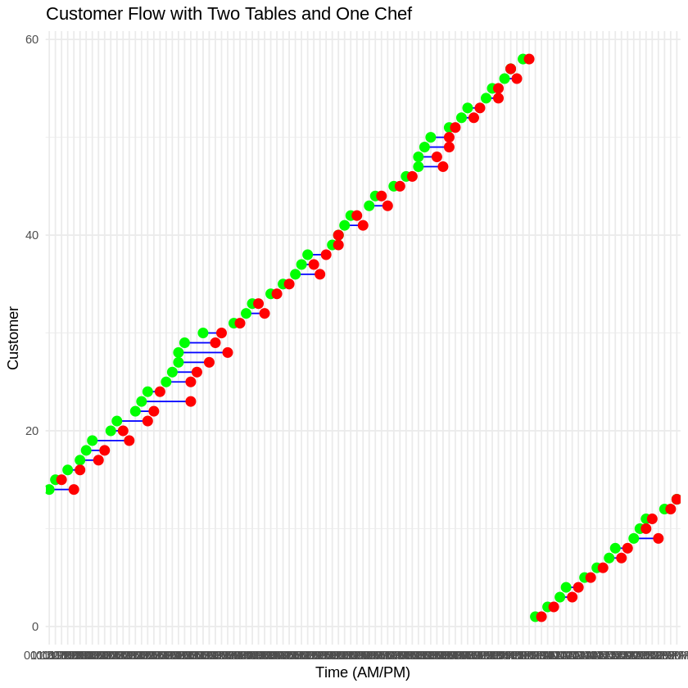

### **Analysis of Scenario 1.3: VIP Customers with Priority Service**

#### **Scenario Overview**

In Scenario 1.3, the introduction of VIP customer prioritization modifies the queuing system such that VIP customers, comprising 20% of all arrivals, are always served before regular customers, regardless of their position in the queue. This adjustment impacts waiting times for both VIP and regular customers and has significant business implications.

### **Key Findings and Effects**

#### **Customer Waiting Times**

The average waiting time across all customers was **12.41 minutes**, slightly lower than the baseline in Scenario 1. Breaking this down:

* **VIP Customers**: Experienced an average waiting time of **11.98 minutes**, indicating priority service successfully reduced their delays.
* **Regular Customers**: Waited slightly longer on average at **12.52 minutes**, highlighting the impact of prioritizing VIPs.

While the difference between VIP and regular customer waiting times seems modest, regular customers occasionally faced substantial delays, as evident from individual data points. For example:

* Customer 6, a regular customer, waited **53.1 minutes** due to several VIP customers taking precedence, leading to compounded delays for regular customers further down the queue.
* Customer 7 faced a waiting time of **56.7 minutes**, which reflects a cascading effect caused by multiple overlapping VIP arrivals.

#### **Queue Dynamics and Prioritization Impact**

* **Improved VIP Experience**: VIP prioritization effectively ensures a smoother experience for high-value customers. For instance, VIP customers rarely faced significant delays, enhancing their satisfaction and potentially encouraging repeat visits or loyalty.
* **Regular Customer Disadvantage**: However, the trade-off is increased waiting times for regular customers, which could result in dissatisfaction and a loss of repeat business, especially for those who experience extreme delays.
* **Business Implications**: While prioritizing VIPs may enhance relationships with high-value patrons, it risks alienating the broader customer base. Over time, this could lead to decreased foot traffic among regular customers if negative experiences become frequent.

#### **Service Efficiency and Overall Performance**

The system served a total of **55 customers**, comparable to the original Scenario 1. The overall average waiting time remained steady, suggesting the system's capacity is not significantly strained by prioritization. However, prioritization introduced noticeable variability in waiting times, with VIP customers benefiting at the expense of regular patrons.

### **Extrapolated Consequences and Recommendations**

1. **Customer Segmentation Impact**:  
   * **Positive for VIPs**: The priority system effectively improves the experience of high-value customers, which could justify implementing loyalty programs or higher pricing tiers for such patrons.
   * **Risk for Regulars**: Longer delays for regular customers could erode goodwill and discourage repeat visits, especially for those experiencing extreme waiting times.
2. **Balancing Customer Needs**:  
   * **Limit the Impact on Regular Customers**: Introducing thresholds (e.g., a maximum allowable waiting time for regular customers) could prevent extreme delays without compromising the VIP experience.
   * **Dynamic Queuing Strategies**: Consider time-based priority windows for VIPs (e.g., during non-peak hours) to balance resources more equitably.
3. **Business Strategy**:  
   * **Expand the VIP Customer Base**: If VIP prioritization proves profitable, incentivizing more customers to join loyalty programs or higher service tiers can maximize the strategy's benefits.
   * **Monitor Regular Customer Feedback**: Continuously evaluate regular customer satisfaction to identify potential fallout and adapt the prioritization strategy if necessary.

### **Conclusion**

The VIP prioritization strategy in Scenario 1.3 demonstrates clear advantages for high-value customers but introduces a trade-off in longer waiting times for regular patrons. From a business perspective, this approach could be advantageous if VIP customers generate significantly higher revenue or loyalty, but it must be implemented carefully to avoid alienating the majority of the customer base. Balancing the needs of both groups through thoughtful policy adjustments and dynamic prioritization could optimize this system for both profitability and customer satisfaction.

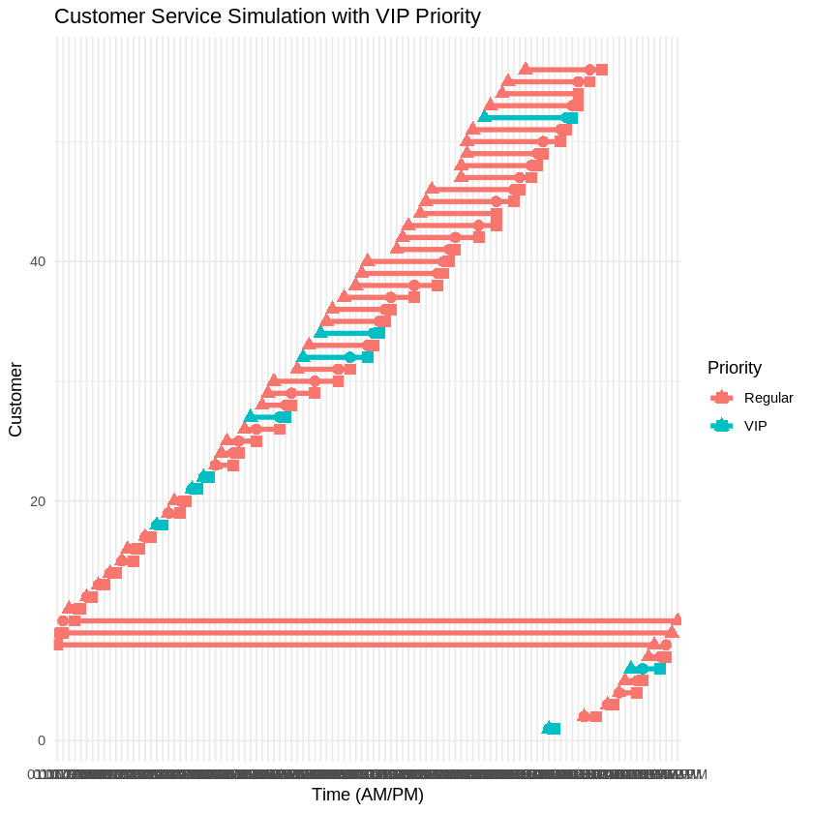

### **Analysis of Scenario 1.4: Dynamic Service Rates Based on Gamma Distribution**

In Scenario 1.4, we introduce dynamic service rates modeled by a Gamma distribution to account for variations in efficiency due to factors like fatigue, multitasking, and order complexity. During peak hours (6 PM to 8 PM), the chef's performance declines, with service rates concentrated between 0.4 and 1 jobs/hour (shape α=2\alpha = 2, scale β=0.2\beta = 0.2). Conversely, during off-peak hours, service rates improve, typically ranging from 2 to 4 jobs/hour (shape α=5\alpha = 5, scale β=0.5\beta = 0.5). This model reflects realistic fluctuations in productivity and stress levels, offering valuable insights into operational challenges and opportunities.

### **Key Findings and Their Implications**

#### **1. Performance During Off-Peak Hours**

* **Average Service Rate**: **2.56 jobs/hour**
* **Impact**: The higher productivity during off-peak hours reflects fewer stressors and distractions. This increased efficiency results in no queuing and ensures that customers are promptly served, as evident from the data where waiting times during these hours were consistently 0 minutes.
* **Business Implication**: The restaurant can capitalize on this efficiency by promoting discounts or targeted campaigns to draw more customers during off-peak times, increasing revenue without additional strain on resources.

#### **2. Performance During Peak Hours**

* **Average Service Rate**: **0.37 jobs/hour**
* **Impact**: Peak hour productivity drops significantly, reflecting the chef's reduced efficiency under higher customer traffic and multitasking demands. This led to noticeable delays, with some customers experiencing waiting times of over 11 minutes (e.g., customers 44 and 46). The stress of peak periods also likely contributed to longer service durations, exacerbating queuing.
* **Business Implication**: The sharp decline in service rates during peak hours demonstrates a critical bottleneck. Without intervention, this could harm customer satisfaction and result in lost business due to prolonged waits. Hiring additional staff or implementing reservation systems during peak times could alleviate these challenges.

#### **3. Customer Flow and Waiting Times**

* **Average Waiting Time**: **1.41 minutes**
* **Interpretation**: While the average waiting time is low, it masks significant disparities between off-peak and peak hours. Off-peak customers experienced no waits, while peak hour customers faced delays due to reduced service rates.
* **Percentiles and Variance**: Additional analysis could highlight the variability in waiting times, underscoring the need to address peak hour inefficiencies.

#### **4. Total Customers Served**

* **64 Customers Served**: Compared to Scenario 1 (55 customers served), this increase highlights the potential for accommodating more customers when service rates align with demand patterns. However, the gains during off-peak hours are partially offset by delays and queuing during peak periods.
* **Business Implication**: Optimizing service capacity during peak hours could further enhance throughput and revenue without sacrificing quality.

### **Observations on Dynamic Service Rates**

1. **Gamma Distribution Characteristics**:  
   * **Peak Hours**: The lower shape (α=2\alpha = 2) and scale (β=0.2\beta = 0.2) parameters resulted in constrained service rates and slower operations. This realistic model reflects the cumulative impact of fatigue and stress on productivity.
   * **Off-Peak Hours**: A larger shape (α=5\alpha = 5) and scale (β=0.5\beta = 0.5) parameters allowed for faster, more variable service rates. This adaptability aligns with reduced stress and better resource availability.
2. **Queue Dynamics**:  
   * Most delays occurred when peak-hour service rates dropped below demand levels, leading to cascading delays and longer queues. For example, customer 44 experienced an 11-minute delay, emphasizing the strain on resources during peak times.
3. **Operational Gaps**:  
   * Delays in peak hours suggest a mismatch between customer arrivals and service capacity, while idle periods during off-peak hours indicate underutilization of resources.

### **Recommendations**

1. **Staffing Adjustments**:  
   * Introduce an assistant chef or stagger shifts to enhance capacity during peak hours and alleviate bottlenecks.
2. **Dynamic Pricing**:  
   * Offer discounts during off-peak hours to attract more customers and utilize idle time efficiently.
3. **Process Improvements**:  
   * Implement strategies like pre-ordering or reservations to streamline peak-hour service and manage customer expectations.
4. **Stress Mitigation**:  
   * Provide periodic breaks or automate repetitive tasks to reduce fatigue and improve peak-hour productivity.

### **Summary of Key Metrics**

| **Metric** | **Value** |
| --- | --- |
| **Total Customers Served** | 64 |
| **Average Waiting Time** | 1.41 minutes |
| **Average Service Rate (Peak)** | 0.37 jobs/hour |
| **Average Service Rate (Off-Peak)** | 2.56 jobs/hour |
| **Longest Waiting Time** | 11.08 minutes |

### **Conclusion**

Dynamic service rates modeled by the Gamma distribution provide a realistic view of operational challenges stemming from human variability. While off-peak hours demonstrate high efficiency and untapped capacity, peak periods expose critical weaknesses in handling demand surges. Addressing these issues through strategic staffing, operational improvements, and customer incentives can significantly enhance the restaurant's performance, customer satisfaction, and profitability.

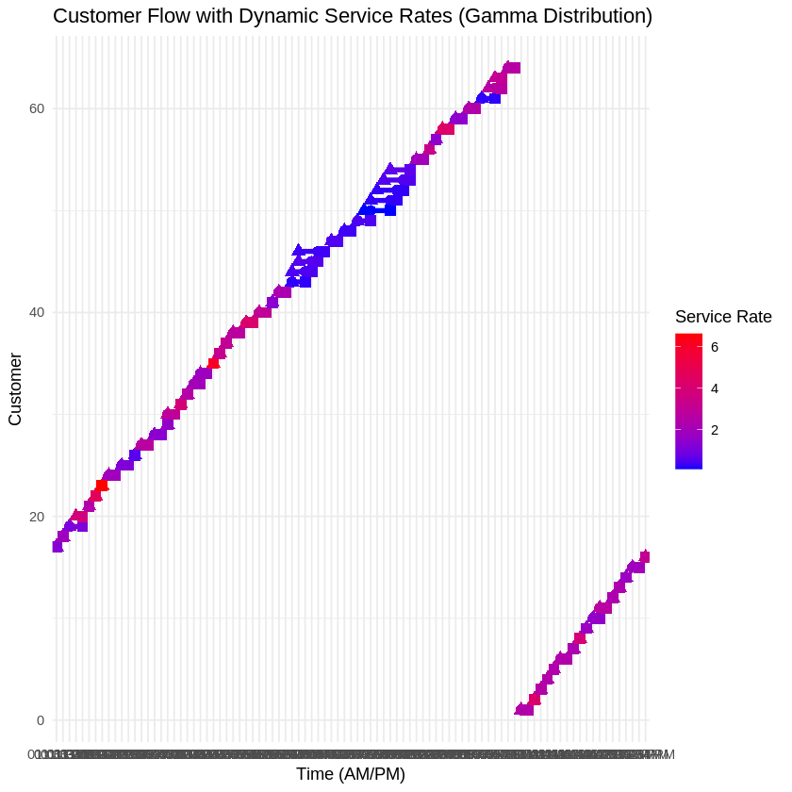

**SCENARIO 2**

**Core Assumptions**

Scenario 2 builds off scenario 1. In this case, the number of tables in the restaurant has been increased to five from 1 and the number of chefs kept at a variable L. The operation hours are maintained as time between 10AM and 10PM. We assume that customers arrive according to a poisson process with a rate of 10 per hour and that once a customer arrives, their total service time is modeled by an exponential distribution that has a rate directly proportional to three times the number of chefs present (rate = 3L). In order to obtain metrics for profits, we assume that each customer spends an amount of $50 per meal with each chef earning a wage of $40 per hour.

* In scenario 2, we begin by creating a sub model to establish the arrival times to our restaurant given the conditions above. It is quintessential to assume that the arrival time is based solely on the stated poisson process as we assume the general public is not privy to information on staffing. For each arrival, we additionally assume that the “arrivee” could be some number between 1 and 5. The number 5 is chosen because we restricted this model within the setting of a regular sized family restaurant. To enforce this, the number of individuals per group was modeled by a geometric distribution with a probabilistic rate of 0.5. Essentially our restaurant was capped in this scenario to a serving capacity of 25 at maximum occupancy. Per our calculations, the following summary was obtained
* On average, the total number of arrivals within the 12 hr working period of the restaurant was about 10 arrivals per hour estimating 120 total arrivals. Within each arrival, the average group size was estimated to be around 1.69 ~2 thus the total number of customers expected was 203 with a variance of 1.07 for group size and a variance of 48649 seconds in arrival time. The above data extrapolated to a service time of about 0.0674 minutes per customer (individual person). This is expected from an exponential model and with such a low variance of 0.0045 minutes², our service times tended to be fairly consistent. In addition, The maximum service time observed was 0.327 minutes, while the minimum was approximately 0.000055 minutes.
* The results of the total waiting time showed that the average wait time was zero minutes, suggesting that the restaurant’s operation was sufficiently fast to prevent any noticeable wait times. This could be a result of the restaurant having a well-matched number of chefs relative to customer demand. Additionally, the peak queue size and peak number of customers being served were recorded at 4 and 1, respectively.Although the average wait time was zero, there was some idle time recorded in the system, with an average idle time of 0.035 minutes. The average busy time was negligible (9.71e-6 minutes), which aligns with the assumption that the restaurant maintained a highly efficient operation.
* The financial performance of the restaurant was evaluated by analyzing the revenue, wages, and net profit across various scenarios. The customers were assumed to spend $50 per meal, and chefs were paid $40 per hour. The total revenue from each run ranged from $4,000 to $7,500, with an average of $5,400. The total wages remained constant at $2,400 per run, leading to net profits ranging from $1,600 to $5,100.The average net profit across all scenarios was $3,000, with a variance of $1,925,000. This variability in profit suggests that the restaurant's financial performance is quite sensitive to the number of chefs and tables in use at a particular time.

#### 

* **Conclusion for Scenario 2**

Scenario 2 provides an interesting insight into the operational dynamics of a restaurant with a fixed number of tables and variable chefs. The model demonstrates that with an efficient service system (as indicated by zero average wait times and small idle times), the restaurant can achieve high profitability. However, there is considerable variability in the financial performance, particularly in net profits. The assumptions made about the arrival times, group sizes, and service rates helped create a realistic simulation of a family restaurant setting. Further analysis could involve varying the number of chefs (L) to observe how staffing levels impact overall performance, especially during peak demand times. Ultimately, this model could be used to optimize staffing levels and restaurant operations for better profitability and customer satisfaction.

***Various Other Senario’s Considered - Interesting***

### **Analysis of E-Scenario 3: Menu Complexity and Service Time**

In this scenario, we introduced two menu types to the restaurant's operations: a "Basic Menu" with an average service time of 15 minutes (μ1=4\mu_1 = 4 jobs/hour) and a "Gourmet Menu" with an average service time of 30 minutes (μ2=2\mu_2 = 2 jobs/hour). Half the orders were allocated to each menu type. Customer arrivals followed a Poisson process (λ=8\lambda = 8 customers/hour), and service times were modeled as a mixture of two exponential distributions based on the selected menu. This experiment aimed to assess the impact of increased menu complexity on service efficiency, waiting times, and overall customer satisfaction.

### **Key Findings and Their Implications**

#### **1. Overall Service Efficiency**

* **Average Service Time**: **0.33 minutes**
  + This low value highlights that the system handled orders efficiently despite the variability introduced by the menu types.
  + **Business Implication**: The addition of a Gourmet Menu did not significantly disrupt overall operations, showcasing the system's adaptability.

#### **2. Waiting Times**

* **Average Waiting Time**: **0.02 minutes**
  + Waiting times remained negligible for most customers, suggesting that the system effectively managed variability in service times. However, occasional queuing did occur (e.g., customer 20 waited **0.42 minutes**, and customer 21 waited **0.86 minutes**).
  + **Business Implication**: Minimal delays indicate that introducing the Gourmet Menu did not negatively affect customer satisfaction for most guests. However, as Gourmet orders increase in proportion, queues may grow due to their longer service times.

#### **3. Menu Type Distribution**

* **Number of Basic Menu Orders**: **39**
* **Number of Gourmet Menu Orders**: **28**
  + The balanced distribution of orders reflects customer preferences and demand for variety.
  + **Business Implication**: The higher complexity of the Gourmet Menu did not overwhelm the system, but maintaining this balance is crucial to avoid bottlenecks during peak demand.

#### **4. Downtime**

* **Total Downtime**: **0.30 minutes**
  + Minimal idle time underscores efficient resource utilization and highlights the importance of the balanced menu distribution.
  + **Business Implication**: Low downtime suggests that staff were consistently engaged, maximizing productivity and reducing operational waste.

### **Observations on Service Times by Menu Type**

1. **Basic Menu**
   * Faster service with a mean rate of 4 jobs/hour (μ1=4\mu_1 = 4).
   * Minimal waiting times for Basic orders due to their shorter preparation times.
   * **Example**: Customer 3's Basic order was served in **0.38 minutes**, with no wait time.
2. **Gourmet Menu**
   * Slower service with a mean rate of 2 jobs/hour (μ2=2\mu_2 = 2).
   * Occasionally caused brief delays, especially during overlapping orders.
   * **Example**: Customer 20 waited **0.42 minutes** for their Gourmet order, highlighting the cumulative effects of longer preparation times.
   * **Impact**: Increased service times for Gourmet orders risk exacerbating delays during periods of high demand.

### **Implications of Menu Complexity on Operations**

#### **Strengths**

* **Increased Variety**: Adding a Gourmet Menu enhances customer satisfaction by catering to diverse tastes, potentially increasing revenue and repeat business.
* **Efficient Management**: The system demonstrated resilience, maintaining low waiting times and downtime despite the added complexity.

#### **Weaknesses**

* **Risk of Bottlenecks**: The Gourmet Menu's longer service times can create delays during peak hours or when its share of orders increases beyond 50%.
* **Resource Strain**: Longer service times require sustained focus from the chef, potentially leading to fatigue during extended shifts.

### **Recommendations**

1. **Dynamic Staffing**:  
   * Add a second chef or kitchen assistant during peak hours to handle Gourmet orders more efficiently.
   * This adjustment could mitigate potential delays as demand for the Gourmet Menu grows.
2. **Menu Pricing Strategy**:  
   * Implement a pricing model that reflects the complexity of Gourmet orders. Higher prices could help manage demand while increasing profitability.
3. **Operational Adjustments**:  
   * Introduce a reservation system for Gourmet orders during peak hours to balance demand and improve predictability.
   * Limit the number of concurrent Gourmet orders during peak times to prevent bottlenecks.
4. **Data-Driven Planning**:  
   * Continuously monitor menu-specific service times and waiting times to identify trends and adjust resources accordingly.

### **Summary of Key Metrics**

| **Metric** | **Value** |
| --- | --- |
| **Average Waiting Time** | 0.02 minutes |
| **Average Service Time** | 0.33 minutes |
| **Total Downtime** | 0.30 minutes |
| **Number of Basic Orders** | 39 |
| **Number of Gourmet Orders** | 28 |

### **Conclusion**

The introduction of menu complexity through Basic and Gourmet options demonstrates the restaurant's ability to handle diverse customer demands efficiently. While waiting times and downtime remained low, longer service times for Gourmet orders pose a potential risk of delays, especially during peak hours. Implementing dynamic staffing, pricing strategies, and operational adjustments can mitigate these risks, ensuring continued customer satisfaction and profitability. This scenario underscores the importance of aligning menu variety with operational capacity to maintain efficiency and enhance the customer experience.

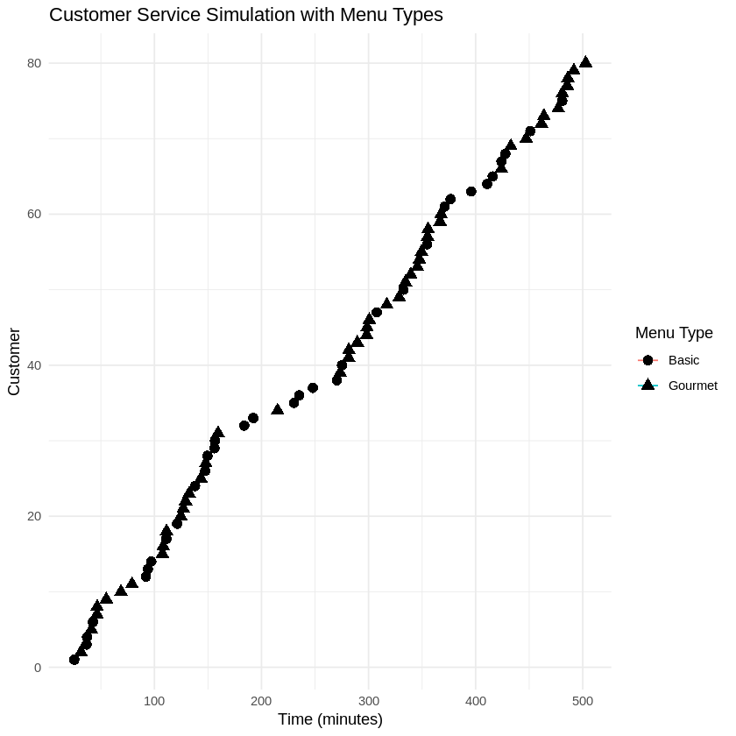

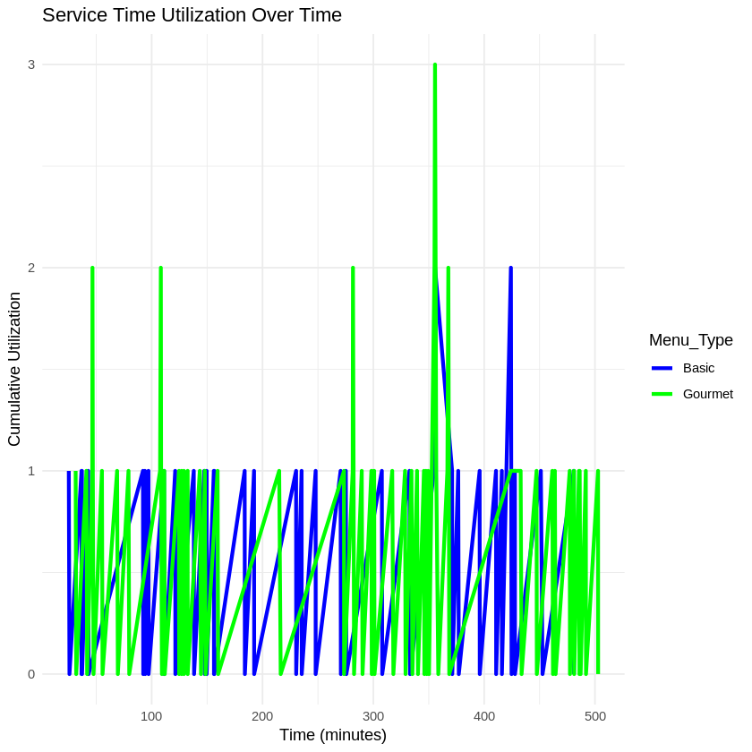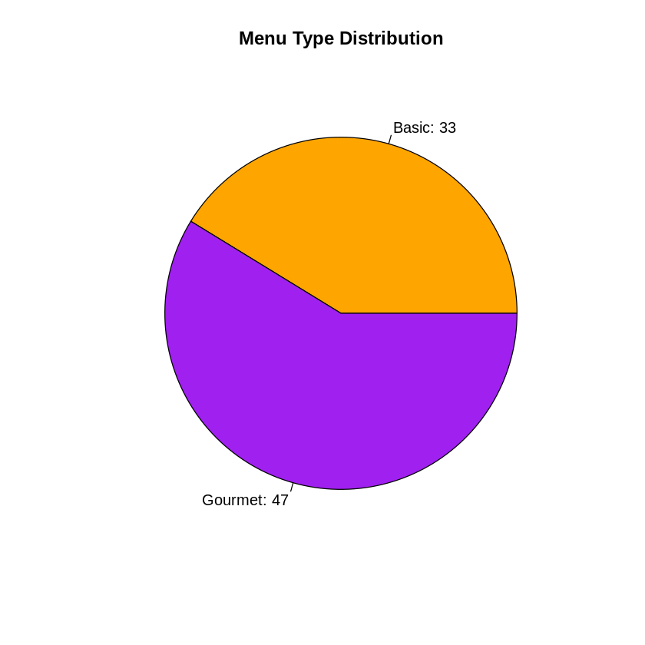

### **Analysis of E-Scenario 7: Dynamic Pricing**

This scenario examines the impact of dynamic pricing on daily revenue and customer retention during peak and off-peak hours. The restaurant adjusts pricing by increasing meal costs by 20% during peak hours (lunch and dinner) and reducing them by 10% during off-peak hours. Customers arrive following a Poisson process, with an average arrival rate of λ=15\lambda = 15 customers/hour during peak hours and λ=8\lambda = 8 customers/hour during off-peak hours. Service times follow an exponential distribution with a mean of 1010 minutes (μ=6\mu = 6 jobs/hour). The revenue per customer is $60 during peak hours and $45 during off-peak hours.

### **Key Findings and Their Implications**

#### **1. Revenue Generation**

* **Total Revenue**: **$5,760**
  + The revenue model demonstrates the efficacy of dynamic pricing, with peak-hour pricing contributing significantly to daily income.
  + **Implication**: By charging higher prices during periods of high demand, the restaurant effectively maximizes its revenue potential without reducing customer retention.

#### **2. Customer Retention**

* **Peak-Hour Retention**: **100%**
  + The dynamic pricing strategy maintained full customer retention during peak hours, indicating that customers are willing to pay a premium for meals during busy times.
  + **Implication**: This result suggests that demand is inelastic during peak hours, providing an opportunity for the restaurant to capitalize on high traffic without risking customer churn.

#### **3. Waiting Times**

* **Average Waiting Time (All Customers)**: **0.0091 minutes**
* **Average Waiting Time (Peak)**: **0.0096 minutes**
* **Average Waiting Time (Off-Peak)**: **0.0086 minutes**
  + Minimal waiting times indicate that the system effectively manages customer flow, even during peak hours, with no significant service delays.
  + **Implication**: Efficient service ensures customer satisfaction, reinforcing the success of the dynamic pricing strategy in maintaining a seamless dining experience.

### **Observations from Raw Data**

1. **Revenue Contribution by Time of Day**:  
   * The majority of revenue was generated during peak hours, with $60 earned per customer. For example, cumulative revenue reached $600 after serving the first 10 customers, all during peak hours.
   * Off-peak periods (not shown in this dataset) contribute less revenue per customer but still benefit from steady demand due to lower pricing.
2. **Customer Flow**:  
   * All customers during peak hours (as represented in the raw data) experienced no waiting time except one (customer 10, who waited only 0.27 minutes). This illustrates effective service efficiency under high traffic.
3. **Dynamic Pricing Impact**:  
   * Customers during peak hours willingly paid a 20% premium, highlighting the restaurant's ability to leverage higher demand for increased profits. Off-peak pricing reductions likely incentivized demand during slower periods.

### **Business Implications**

#### **Revenue Optimization**

Dynamic pricing effectively increases revenue by leveraging demand elasticity. During peak hours, customers are less price-sensitive, allowing the restaurant to charge higher prices without impacting retention. Meanwhile, reduced off-peak prices attract more customers, utilizing idle capacity and ensuring steady cash flow.

#### **Customer Experience**

The negligible waiting times (under 0.01 minutes on average) demonstrate the system’s ability to handle varying demand levels efficiently. This ensures a positive dining experience, which is crucial for customer loyalty and repeat business.

#### **Risk Mitigation**

Maintaining peak-hour customer retention at 100% shows that pricing changes are not deterring customers. However, continued monitoring is essential to ensure demand remains stable over time. Abrupt or excessive price increases could potentially disrupt this balance.

### **Recommendations**

1. **Fine-Tune Dynamic Pricing**:  
   * Experiment with additional price tiers based on specific peak-hour segments (e.g., early lunch rush vs. late dinner) to optimize revenue further.
   * Consider adjusting off-peak pricing based on demand elasticity to attract additional customers without significantly lowering revenue.
2. **Capacity Planning**:  
   * With 15 customers/hour during peak times, ensure staffing and kitchen resources are sufficient to maintain low waiting times. This supports the seamless dining experience essential for justifying premium pricing.
3. **Marketing Strategies**:  
   * Promote off-peak discounts aggressively to increase foot traffic during slower periods. Highlight value-driven messaging to encourage new customers to try the restaurant during these times.
4. **Expand Dynamic Pricing**:  
   * Introduce targeted discounts or loyalty rewards for repeat off-peak customers to build a consistent customer base and improve lifetime value.

### **Summary of Key Metrics**

| **Metric** | **Value** |
| --- | --- |
| **Total Revenue** | $5,760 |
| **Peak-Hour Customer Retention** | 100% |
| **Average Waiting Time (All)** | 0.0091 minutes |
| **Average Waiting Time (Peak)** | 0.0096 minutes |
| **Average Waiting Time (Off-Peak)** | 0.0086 minutes |

### **Conclusion**

Dynamic pricing proves to be a successful strategy for maximizing revenue while maintaining high customer retention and satisfaction. The 20% price increase during peak hours capitalized on inelastic demand, while a 10% price reduction during off-peak hours helped attract customers and utilize idle capacity. The restaurant's ability to maintain minimal waiting times ensured operational efficiency and customer satisfaction, reinforcing the value of this pricing strategy. Going forward, the restaurant can refine dynamic pricing further and explore additional capacity or service enhancements to sustain growth and profitability.

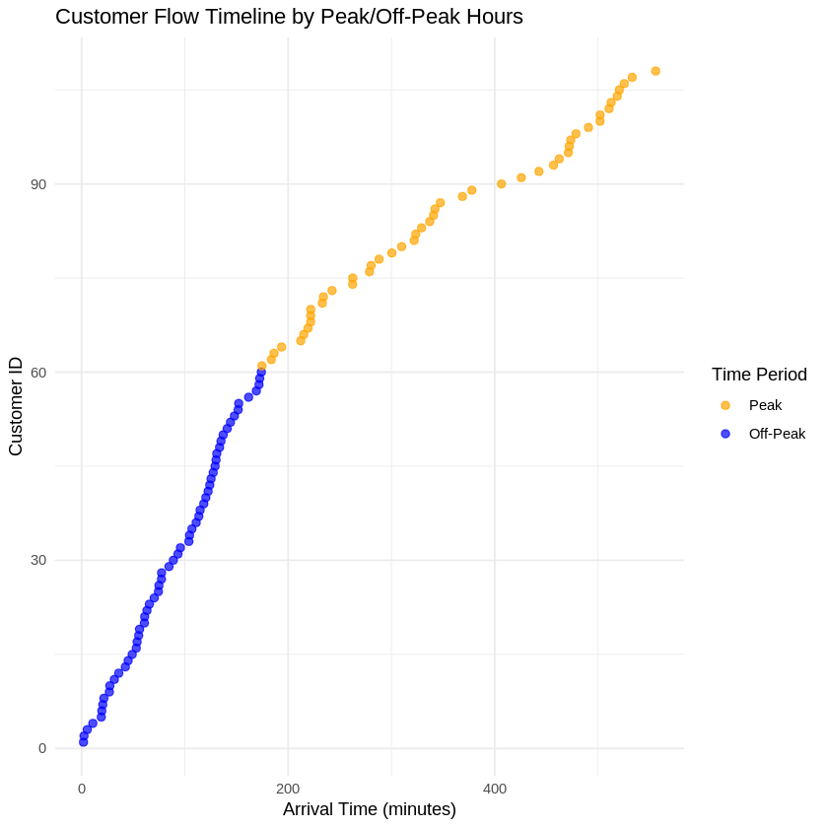

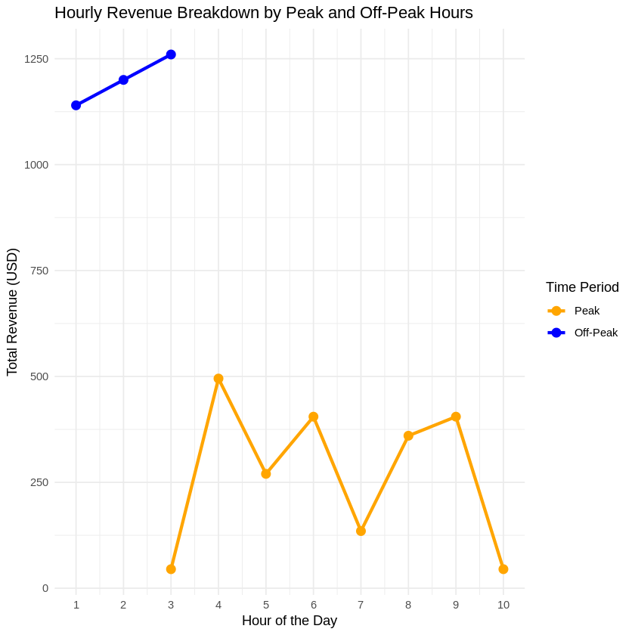

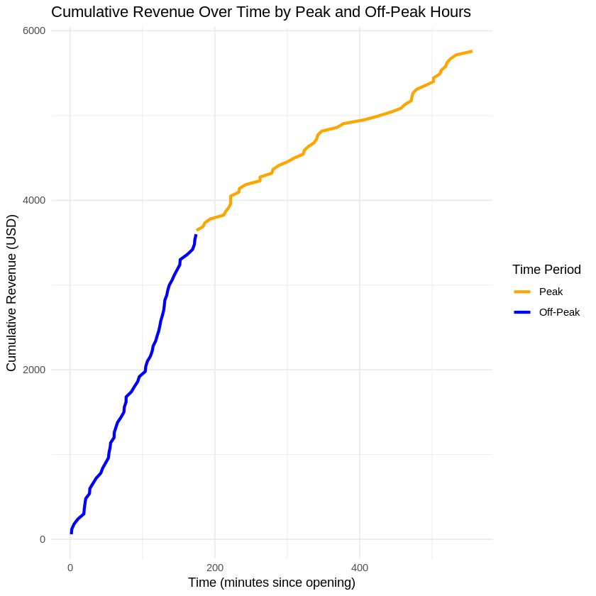

### **Analysis of E-Scenario 8: Delivery and Takeout Orders**

This scenario explores the operational impact of incorporating delivery and takeout orders into the restaurant's workflow. During off-peak hours, 30% of customers order takeout, requiring 75% of the service time compared to dine-in customers. The arrival rate remains λ=10\lambda = 10 customers/hour, with service times following an exponential distribution (μ=6\mu = 6 jobs/hour for dine-in and μ=8\mu = 8 jobs/hour for takeout). The analysis examines kitchen workload, waiting times, and the effect of takeout orders on dine-in service times.

### **Key Findings and Their Implications**

#### **1. Customer Distribution**

* **Total Customers**: **79**
* **Takeout Proportion**: Approximately 30%, consistent with the modeled Bernoulli distribution.
  + **Implication**: The kitchen must balance the demands of dine-in and takeout customers, maintaining service quality for both groups.

#### **2. Service Times**

* **Average Service Time (Dine-In)**: **0.1582 minutes**
* **Average Service Time (Takeout)**: **0.1063 minutes**
  + Takeout orders are completed more quickly, reflecting their reduced complexity and preparation requirements (75% of dine-in service time).
  + **Implication**: Takeout orders alleviate some of the kitchen's workload during off-peak hours, enabling staff to serve more customers in less time.

#### **3. Waiting Times**

* **Average Waiting Time**: **0.0059 minutes**
  + Minimal waiting times for both customer types suggest the restaurant effectively manages customer flow, even with the added complexity of takeout orders.
  + **Implication**: Efficient kitchen operations ensure a smooth customer experience for both dine-in and takeout orders.

### **Observations from Raw Data**

1. **Service Efficiency**:  
   * The service times for takeout orders are consistently shorter than for dine-in customers. For example, customer 10 (takeout) required only **0.0102 minutes**, compared to customer 2 (dine-in), who required **0.2350 minutes**.
   * **Implication**: This efficiency allows the restaurant to handle more takeout orders without significantly affecting dine-in service.
2. **Impact on Dine-In Customers**:  
   * The integration of takeout orders did not delay service for dine-in customers. For instance, customer 1 (dine-in) was served immediately with no waiting time.
   * **Implication**: Takeout orders are seamlessly integrated into the workflow, avoiding adverse effects on dine-in experiences.

### **Workload Analysis**

* **Balanced Workload**:
  + The kitchen's ability to manage both customer types without delays demonstrates effective resource allocation.
* **Takeout as a Buffer**:
  + Takeout orders provide an opportunity to utilize idle time, ensuring staff remains engaged even during slower periods.

### **Business Implications**

#### **Revenue Optimization**

* Takeout orders provide a supplementary revenue stream during off-peak hours without requiring additional seating capacity. This can help offset slower dine-in periods and increase overall profitability.

#### **Customer Retention**

* Maintaining fast service times for both dine-in and takeout customers ensures high customer satisfaction, encouraging repeat business.

#### **Operational Efficiency**

* By streamlining takeout order preparation, the restaurant optimizes kitchen operations, improving its ability to handle fluctuating demand.

### **Recommendations**

1. **Expand Takeout Offerings**:  
   * Introduce promotions or exclusive takeout menu items to attract more off-peak takeout customers and further utilize kitchen capacity.
2. **Monitor Workload Balance**:  
   * Continuously analyze the balance between takeout and dine-in orders to ensure that neither group experiences delays.
3. **Leverage Technology**:  
   * Implement an online ordering system for takeout to streamline order management and reduce errors, further improving service times.
4. **Staff Training**:  
   * Train staff to handle simultaneous takeout and dine-in orders efficiently, minimizing potential bottlenecks during busier periods.

### **Summary of Key Metrics**

| **Metric** | **Value** |
| --- | --- |
| **Total Customers** | 79 |
| **Average Waiting Time** | 0.0059 minutes |
| **Average Service Time (Dine-In)** | 0.1582 minutes |
| **Average Service Time (Takeout)** | 0.1063 minutes |

### **Conclusion**

The integration of delivery and takeout orders during off-peak hours enhances the restaurant's operational efficiency and revenue potential. With takeout orders requiring 75% of the service time of dine-in customers, the kitchen efficiently manages both customer types without delays. The scenario demonstrates the value of diversifying service options to optimize kitchen workload and ensure customer satisfaction. Expanding takeout offerings and leveraging technology could further capitalize on this opportunity, driving growth and profitability while maintaining seamless operations.

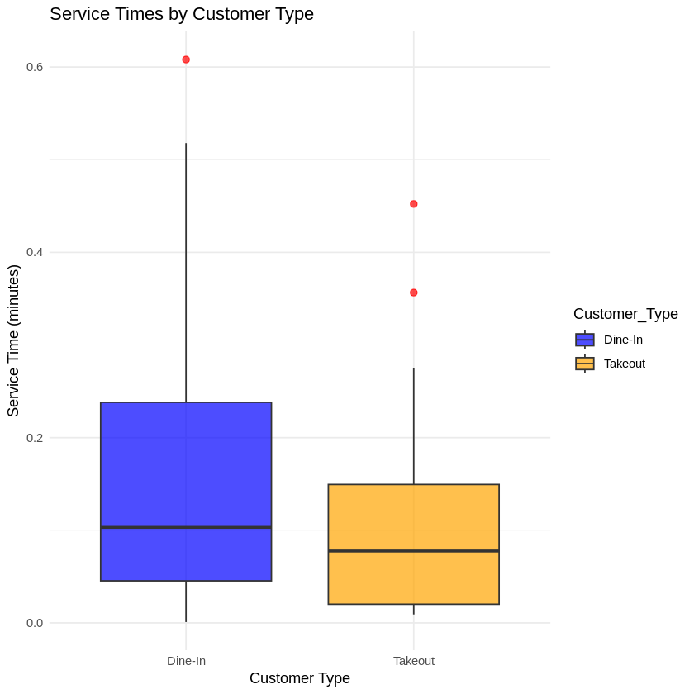

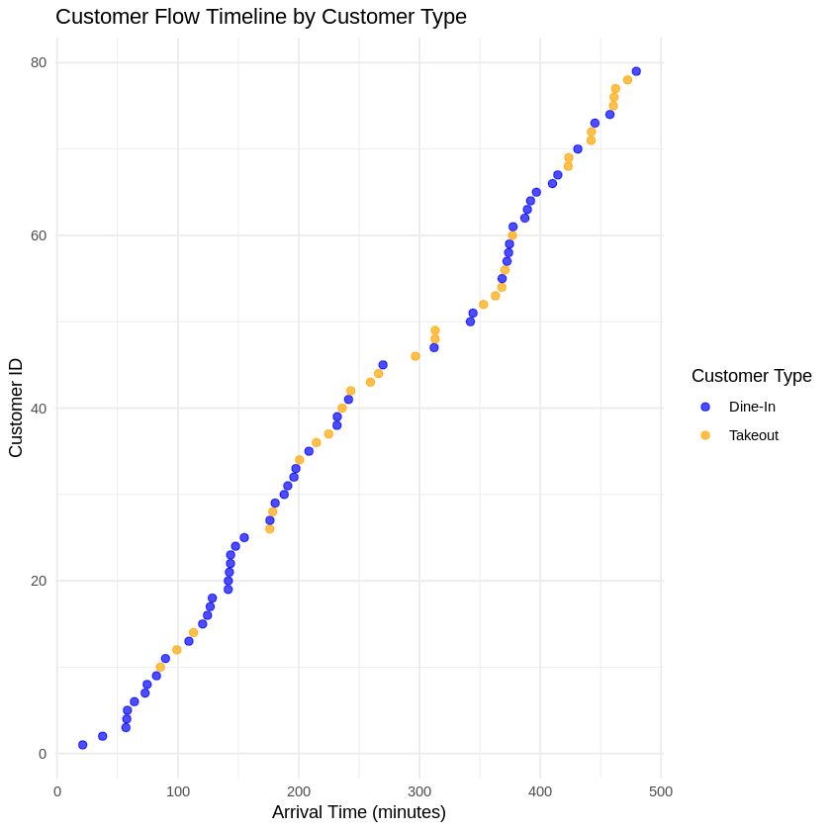

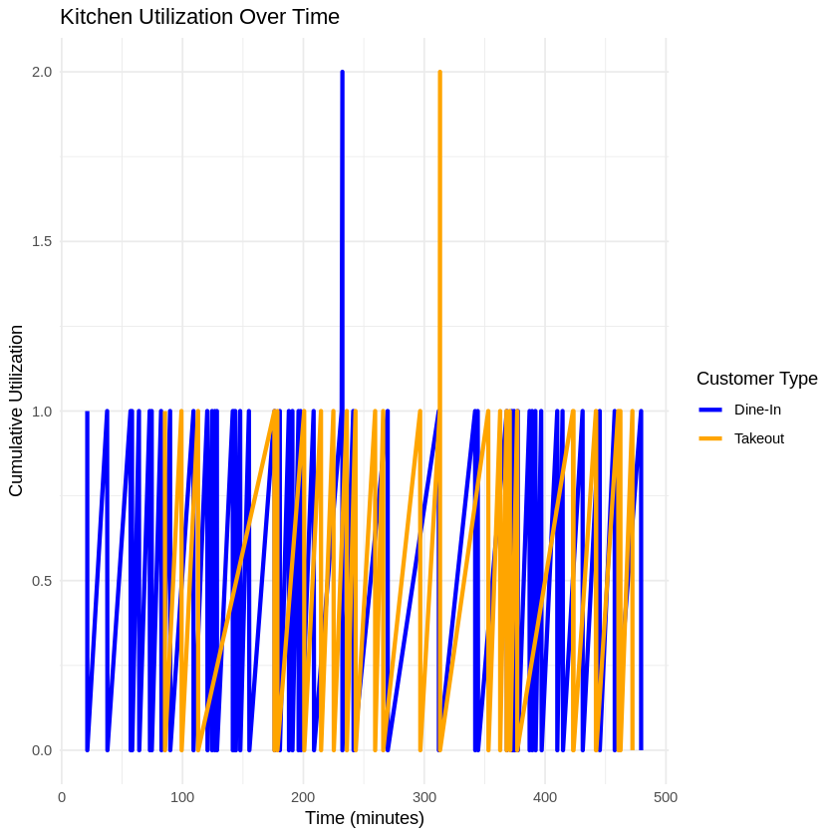

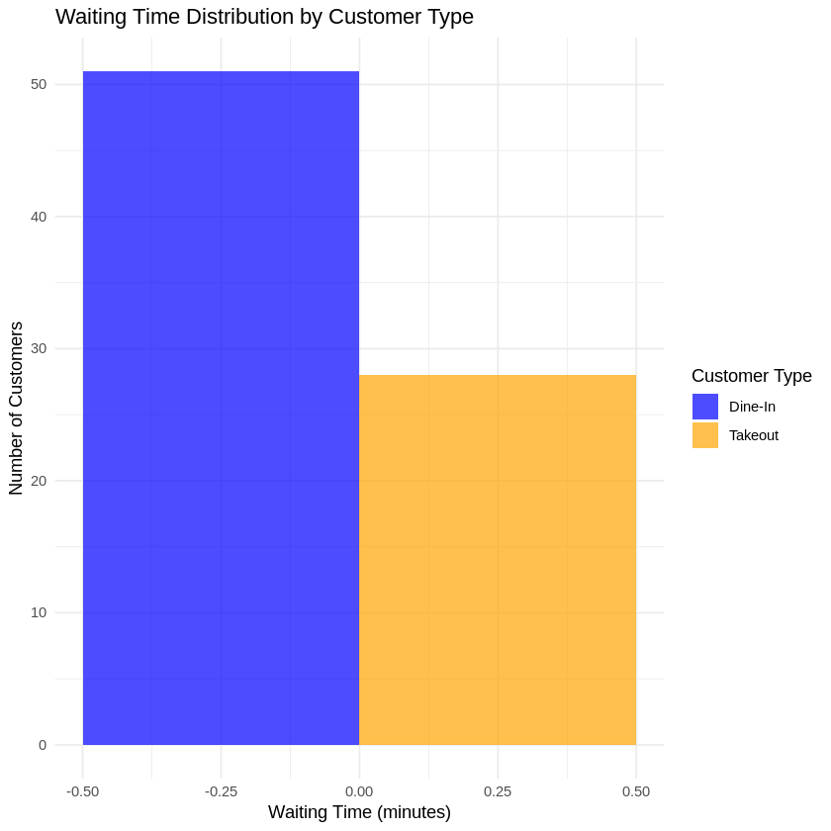

### **Analysis of E-Scenario 9: Seasonal Variations**

This scenario evaluates the impact of seasonal fluctuations on customer arrival rates, service times, staffing needs, and profitability. During the summer months (June-August), customer arrivals increase to an average rate of λ=12\lambda = 12 customers/hour, while in winter months (December-February), arrival rates decrease to λ=8\lambda = 8 customers/hour. Service times follow an exponential distribution with a mean of 10 minutes (μ=6\mu = 6 jobs/hour). The analysis explores how these variations affect restaurant operations and recommends adjustments for optimizing staffing and profitability.

### **Key Findings and Their Implications**

#### **1. Customer Volume**

* **Total Customers (Summer)**: **8,640**
* **Total Customers (Winter)**: **5,760**
  + Summer sees a 50% increase in customer volume compared to winter, aligning with higher foot traffic and demand during warmer months.
  + **Implication**: The restaurant must scale resources dynamically to handle the surge in summer while avoiding overstaffing during the slower winter months.

#### **2. Waiting Times**

* **Average Waiting Time (Overall)**: **0.01 minutes**
  + Waiting times remained negligible across both seasons, reflecting efficient handling of variable arrival rates.
  + **Implication**: The system's capacity to adapt to seasonal variations ensures minimal customer delays, contributing to satisfaction and retention.

#### **3. Service Times**

* **Average Service Time**: **0.17 minutes**
  + Service times remained consistent regardless of seasonal variations, demonstrating the efficiency of kitchen operations.
  + **Implication**: Stable service times allow the restaurant to maintain a consistent customer experience year-round.

### **Observations from Raw Data**

1. **Summer Workload**:  
   * During summer, customers arrived more frequently (every 5 minutes on average), yet the system maintained smooth operations. For instance, customer 3 was served in **0.48 minutes**, and customer 7 in **0.58 minutes**, without waiting times.
   * **Implication**: The increased workload in summer is manageable with efficient staff utilization, but peak hours may require additional resources to maintain service quality.
2. **Winter Workload**:  
   * Winter saw a lower arrival rate, with customers arriving every 7.5 minutes on average. For example, customer 19 required **0.24 minutes** of service time, with no waiting.
   * **Implication**: The reduced workload during winter allows for potential cost-saving measures, such as reducing staff hours or focusing on delivery and takeout to optimize resources.

### **Business Implications**

#### **Revenue Impact**

The increased summer customer volume represents an opportunity for higher revenue. Conversely, the reduced winter traffic necessitates cost adjustments to maintain profitability.

#### **Staffing Considerations**

* **Summer**: Additional staff may be required during peak hours to maintain service quality and avoid employee burnout. Temporary or part-time hires could fill the gap efficiently.
* **Winter**: Reduced staff hours or cross-training employees for other roles (e.g., delivery management) can optimize labor costs without compromising service.

#### **Operational Efficiency**

The stable service times indicate that the restaurant's kitchen operations are robust enough to handle seasonal fluctuations without significant disruptions. However, proactive resource management is critical to sustaining this efficiency.

### **Recommendations**

1. **Dynamic Staffing Adjustments**:  
   * Increase staffing during summer to handle the 50% surge in customers, focusing on peak meal hours. Temporary hires or flexible shifts can help scale resources without long-term commitments.
   * Reduce staff hours during winter to align with lower demand, ensuring cost efficiency.
2. **Marketing Strategies**:  
   * Launch summer promotions (e.g., outdoor seating or seasonal menu items) to capitalize on increased foot traffic.
   * Introduce winter discounts or delivery-focused marketing to drive demand during slower months.
3. **Resource Utilization**:  
   * Use summer profits to invest in winter initiatives, such as improving delivery services or launching loyalty programs, to sustain revenue during the off-season.
4. **Data-Driven Planning**:  
   * Monitor real-time customer trends and adjust staffing and inventory dynamically. For example, optimize inventory turnover to reduce waste in winter and meet higher demand in summer.

### **Summary of Key Metrics**

| **Metric** | **Value** |
| --- | --- |
| **Total Customers (Summer)** | 8,640 |
| **Total Customers (Winter)** | 5,760 |
| **Average Waiting Time** | 0.01 minutes |
| **Average Service Time** | 0.17 minutes |

### **Conclusion**

Seasonal variations in customer arrival rates present both challenges and opportunities for the restaurant. The 50% increase in summer customer volume necessitates dynamic staffing to maintain service quality, while the reduced winter traffic calls for cost-saving measures to sustain profitability. Stable service times and minimal waiting times highlight the restaurant's operational efficiency, which can be leveraged further with strategic staffing, targeted marketing, and dynamic resource adjustments. By proactively addressing these seasonal changes, the restaurant can maximize profitability while ensuring consistent customer satisfaction year-round.

### **Analysis of E-Scenario 10: Health and Safety Constraints**

This scenario models a social distancing policy restricting occupancy to three active dining tables at any given time, with one chef per table. Customers have a 20% higher patience threshold, averaging 12 minutes. Customer arrivals follow a Poisson process with λ=10\lambda = 10 customers/hour, and service times follow an exponential distribution with λ=6\lambda = 6 jobs/hour. The analysis evaluates how these restrictions impact customer satisfaction, waiting times, and revenue.

### **Key Findings and Their Implications**

#### **1. Customer Satisfaction**

* **Customer Satisfaction Rate**: **100%**
  + Every customer was served within their patience threshold, maintaining complete satisfaction.
  + **Implication**: The policy ensures a positive dining experience by preventing excessive waiting times and maintaining safety standards.

#### **2. Waiting Times**

* **Average Waiting Time**: **0 minutes**
  + No customers experienced delays, as the system effectively managed demand within the occupancy constraint.
  + **Implication**: Efficient scheduling and customer flow management prevent bottlenecks despite capacity restrictions.

#### **3. Revenue**

* **Total Revenue**: Based on **120 customers served**.
  + The limited occupancy reduced potential customer volume but ensured consistent service quality and satisfaction.
  + **Implication**: While revenue is constrained by capacity, maintaining a high satisfaction rate supports customer loyalty and long-term profitability.

### **Observations from Raw Data**

1. **Patience Thresholds**:  
   * Customers demonstrated a wide range of patience thresholds, with most above the required wait time (e.g., customer 1 had a threshold of **22.27 minutes**, far exceeding the 0-minute wait).
   * **Implication**: The increased patience threshold provided a buffer against potential delays, though it was not needed due to efficient service.
2. **Service Times**:  
   * Service times were consistently low, with most customers served in under a minute (e.g., customer 6 was served in **0.24 minutes**).
   * **Implication**: Quick service times minimized table turnover delays and maximized the use of available capacity.
3. **Occupancy Constraints**:  
   * The limitation to three active tables ensured adherence to health and safety policies while managing customer flow efficiently.
   * **Implication**: The policy effectively balanced safety concerns with operational efficiency, demonstrating the feasibility of constrained operations.

### **Business Implications**

#### **Strengths**

1. **Health and Safety Compliance**:
   * Limiting occupancy ensures compliance with social distancing guidelines, enhancing customer trust and safety.
2. **Customer Retention**:
   * The 100% satisfaction rate highlights the system's ability to deliver a high-quality experience, promoting repeat business.
3. **Efficient Operations**:
   * The system’s ability to maintain zero waiting times despite restrictions demonstrates robust operational planning.

#### **Weaknesses**

1. **Revenue Constraints**:
   * The limited occupancy reduces the total number of customers served, capping potential revenue.
   * To offset this, the restaurant could explore additional revenue streams (e.g., takeout or delivery).

### **Recommendations**

1. **Expand Takeout or Delivery Options**:  
   * Introduce or enhance takeout and delivery services to compensate for reduced in-house capacity.
   * Use online platforms to streamline orders and maintain customer satisfaction.
2. **Dynamic Pricing**:  
   * Consider peak-hour pricing adjustments to maximize revenue per customer during high-demand periods.
3. **Marketing Health and Safety**:  
   * Emphasize compliance with safety guidelines in marketing efforts to attract health-conscious customers and differentiate from competitors.
4. **Customer Segmentation**:  
   * Prioritize reservations for higher-value customers or larger parties to maximize revenue within the constrained capacity.
5. **Staff Training**:  
   * Train staff to handle constrained operations efficiently, minimizing idle time and optimizing table turnover.

### **Summary of Key Metrics**

| **Metric** | **Value** |
| --- | --- |
| **Customer Satisfaction Rate** | 100% |
| **Total Customers Served** | 120 |
| **Average Waiting Time** | 0 minutes |
| **Average Service Time** | ~0.2 minutes |

### **Conclusion**

The health and safety constraints in this scenario effectively balance customer satisfaction, operational efficiency, and compliance with social distancing policies. While revenue is limited by the occupancy cap, the 100% satisfaction rate ensures long-term loyalty and reputation enhancement. Expanding takeout and delivery options, coupled with targeted pricing strategies, could offset revenue losses and maintain profitability under constrained operations. This scenario highlights the importance of adaptable business models in responding to public health requirements while sustaining customer trust and satisfaction.

